1. 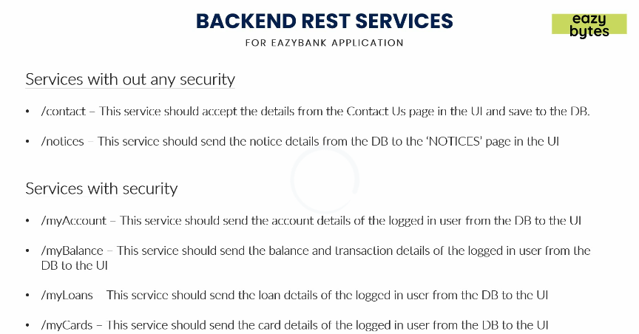
2. 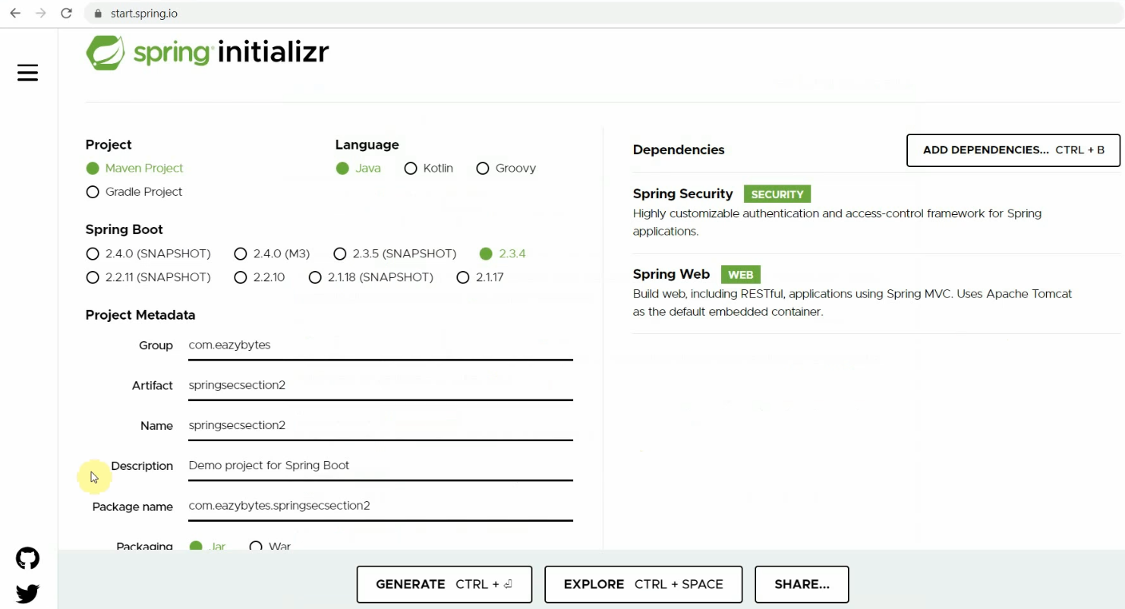
3. Import the project after downloading the skeleton project.
4. 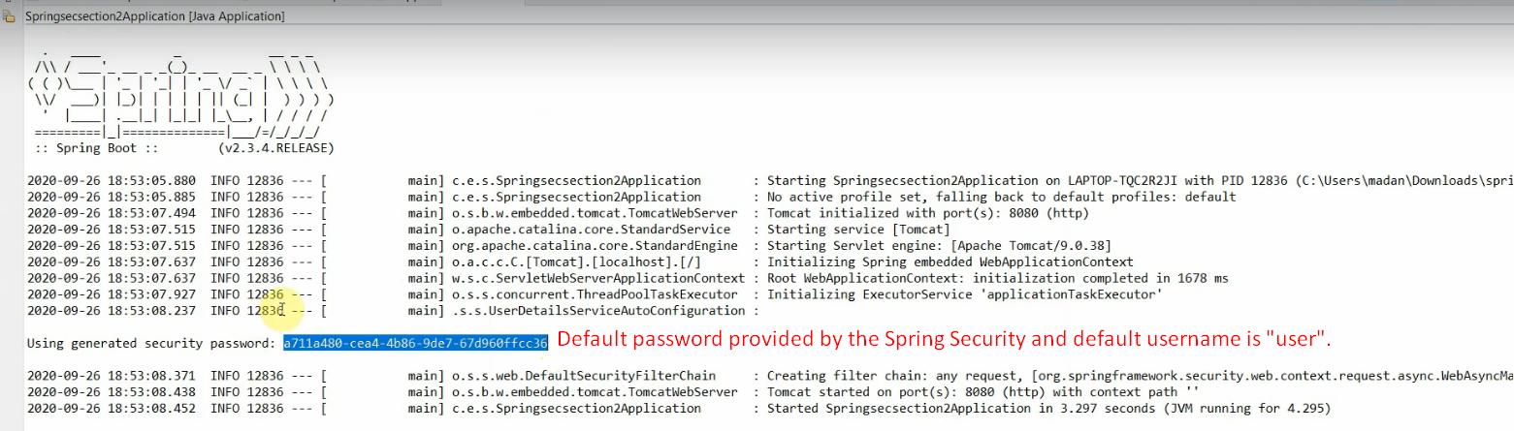
5. We can override the default configurations by application.properties file.
6. 
7. 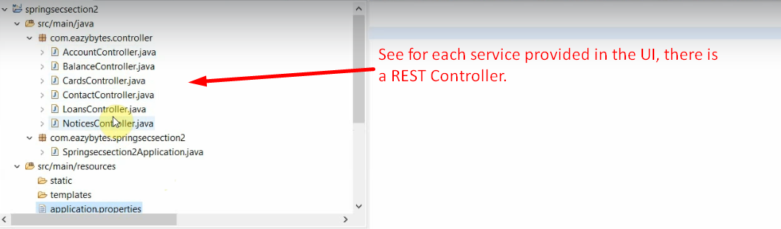
8. 